Introduced by the Council President at the request of the Context Sensitive Streets Standards Committee and Co-Sponsored by Council Member Becton:
ORDINANCE 2017-807
AN ORDINANCE AMENDING CHAPTER 804(JACKSONVILLE TRAFFIC CODE) CREATING A NEW PART 15(TRUCK ROUTE REGULATIONS),ORDINANCE CODE; CREATING A NEW SECTION 804.1501 (PURPOSE AND INTENT), ORDINANCE CODE; CREATING A NEW SECTION 804.1502 (DEFINITIONS), ORDINANCE CODE; CREATING A NEW SECTION 804.1503(TRUCK ROUTE CRITERIA), ORDINANCE CODE; CREATING NEW SECTION 804.1504(DESIGNATED TRUCK ROUTES AND MAPS), ORDINANCE CODE; CREATING A NEW SECTION 804.1505 (SIGNAGE); CREATING A NEW SECTION 804.1506 (EVIDENCE REQUIRED FOR DEVIATION; ENFORCEMENT; PENALTIES);PLANNING AND DEVELOPMENT DEPARTMENT TO PROVIDE EDUCATIONAL COMPONENT; PROVIDING FOR AN EFFECTIVE DATE.

WHEREAS, the City of Jacksonville (“City”) contains numerous truck traffic generators and destinations including the Jacksonville Port Authority (JAXPORT) international seaports, industrial and commercial sites, warehouses, intermodal train yards and the Jacksonville International Airport; and
WHEREAS, truck movement is essential to providing the vital goods and services citizens need in daily interactions; and
WHEREAS, the efficient movement of trucks benefits residents by reducing the cost of shipping goods and contributes to the economic growth of the municipality; and
WHEREAS, by establishing appropriate truck routes designed with inputs from the trucking industry and the affected community, the City can help ensure that mobility for all roadway users are preserved, and freight and goods can move safely and efficiently, and the local economy continues to grow; and
WHEREAS, the purpose of a truck route system is to provide guidelines that balance the needs of interstate commerce and the trucking industry with the desire to minimize the impacts of trucks on sensitive land uses; and
WHEREAS, a truck route system does not prohibit trucks from using any road within a municipality, but does require the use of those roads that are more suitable to the greatest extent possible, and also limit truck intrusion into sensitive areas to as minimal as possible; and
WHEREAS, Goal 10, of the 2030 Comprehensive Plan, entitled, “Intermodal Transportation Systems,” states that Interagency coordination and implementation of an intermodal transportation system which integrates highway, mass transit, port, airport, rail, and other transportation modes and facilities shall be supported; and
WHEREAS, Policy 10.6.4 of the 2030 Comprehensive Plan provides that the City shall designate truck routes to minimize the impact of traffic through residential areas and maximize the flow of intermodal shipment of goods; and
WHEREAS, Section 32.702 (a), Ordinance Code, authorizes the Context Sensitive Streets Standards Committee to review, revise and recommend amendments to the Ordinance Code relating to transportation and traffic engineering; and
WHEREAS, Section 32.702 (f), Ordinance Code, also authorizes the Context Sensitive Streets Standards Committee to adopt policies and set guidelines for those streets classified as “Major Truck Streets”; and
WHEREAS, during a noticed public meeting held on July 27, 2016, the Context Sensitive Streets Standards Committee voted to designate Truck Routes for the City of Jacksonville (the minutes of the July 27, 2016, CSSSC meeting are attached and incorporated as Exhibit 1); now therefore
Be it ordained by the Council of the City of Jacksonville:
Section 1. Chapter 804 (Jacksonville Traffic Code), Ordinance Code, amended. Chapter 804 (Jacksonville Traffic Code), Ordinance Code, is hereby amended to read as follows:
CHAPTER 804. JACKSONVILLE TRAFFIC CODE.
* * *
PART 15. – TRUCK ROUTE REGULATIONS
Sec. 804.1501 – Purpose & Intent
The City of Jacksonville (“City”) recognizes the various changes occurring to the transportation network, and acknowledges the need to examine its unique truck traffic situation, and determine a solution that mutually serves the unique needs of the local community. The purpose of this system is to establish truck routes within the City that promote compatible land uses, enhance public safety, and minimize pavement maintenance and reconstruction costs in conjunction with the following:
- Provide safe roadways for vehicles, bicyclists, and pedestrians;
- Provide truck routes that follow the guidance contained in the City’s 2030 Comprehensive Plan;
- Designate acceptable routes for trucks to access the Strategic Intermodal System (SIS) and State Highway System (SHS) in order to complete extended distance travel;
- The City Traffic Engineer to erect signage designating the truck route system;
- Provide for the transportation of heavier products on roads (truck routes) best designed to handle the additional pavement stress in order to minimize the amount of maintenance and repair costs required on Jacksonville streets;
- Restrict the gross vehicle weight of vehicles traveling on non-truck route roads except where the use of these roads is necessary to travel from the point of origin within the City to the nearest truck route, or from a truck route to a destination point within the City;
- Limit the number of truck routes to minimize the number of streets that require additional pavement construction and frequent maintenance work;
- Protect residential neighborhoods from:
- Excessive truck traffic creating greater hazards to pedestrians, bicyclists, and children;
- Increased congestion and noise pollution from truck traffic; and
- Pavement pot holes, raveling, rutting, or other pavement distress conditions that cause hazards to motorcyclists, bicyclists, and pedestrians;

- Procedures for enforcing truck route violations;
- During emergency situations, the Director of Public Works or his/her designee shall have the authority to further restrict loads or create detours for vehicles traveling on City roads.
Sec. 804.1502 – Definitions.
AASHTO means the American Association of State Highway and Transportation Officials.
FHWA means the Federal Highway Administration.
Gross Weight means the net weight of a motor vehicle in pounds plus the weight of the load carried by it. Florida Statute 320.01(7).
Heavy truck means any motor vehicle with an actual scale weight in pounds with complete catalog equipment of more than 10,000 pounds, which is registered on the basis of gross vehicle weight in accordance with F.S. § 320.08(4), and which is designed or used for the carriage of goods or designed or equipped with a connecting device for the purpose of drawing a trailer that is attached or coupled thereto by means of such connecting device and includes any such motor vehicle to which has been added a cabinet box, a platform, a rack, or other equipment for the purpose of carrying goods other than the personal effects of the passengers.
Light-duty truck, as defined in 40 C.F.R. 86.082-2, means any motor vehicle rated at 8,500 pounds Gross Vehicular Weight Rating or less which has a vehicular curb weight of 6,000 pounds or less and which has a basic vehicle frontal area of 45 square feet or less, which is:
- Designed primarily for purposes of transportation of property or is a derivation of such a vehicle; or
- Designed primarily for transportation of persons and has a capacity of more than 12 persons; or
c)Available with special features enabling off-street or off-highway operation and use.
Net weight means the actual scale weight in pounds with complete catalog equipment.
Truck means any motor vehicle with a net vehicle weight of 5,000 lbs. or less which is designed or used principally for the carriage of goods and includes a motor vehicle which a box, platform, rack or other equipment for the purpose of carrying goods other than personal effects of the passengers as also defined in Section 320.01 (9), Florida Statutes.
Regulated truck means every vehicle meeting one (1) or more of the following criteria:
(1) A vehicle with six (6) or more tires, except step-vans, pickup trucks with dual wheels on the rear axle, and pickup trucks with a capacity of one (1) ton or less; or
(2) A vehicle required by law to display a DOT number or gross vehicle weight (GVW) rating.
(The addition of a trailer to a vehicle that is not otherwise a regulated truck does not make that vehicle a regulated truck). Types of Trucks means the American Association of State Highway and Transportation Officials (AASHTO) has developed a classification system that identifies trucks by their approximate height, width, and length. This classification ranges from the SU-30 Single Unit truck (e.g., cement trucks, large rental trucks, local delivery trucks) to the WB-67 Interstate truck (large semi-trailer with sleeper cab equipped tractor; this class also includes double and triple trailer combinations). See Chart and Truck Classes below.
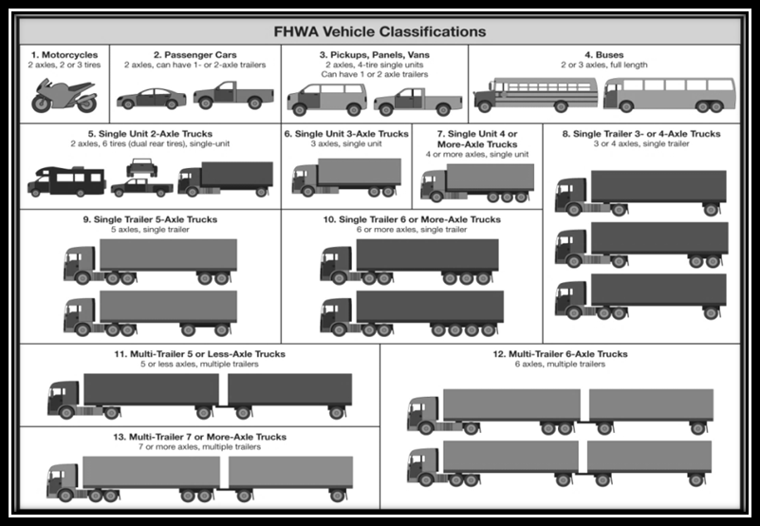
- Class 5- Two-Axle, Six-Tire, Single Unit Trucks: All vehicles on a single frame including trucks, camping and recreational vehicles, motor homes, etc., having two axles and dual rear wheels.
- Class 6- Three-axle Single unit Trucks: All vehicles on a single frame including trucks, camping and recreational vehicles, motor homes, etc., having three axles.
- Class 7- Four or More Axle Single Unit Trucks: All trucks on a single frame with four or more axles.
- Class 8- Four or Less Axle Single Trailer Trucks: All vehicles with four or less axles consisting of two units, one of which is a tractor or straight truck power unit.
- Class 9- Five-Axle Single Trailer Trucks: All five-axle vehicles consisting of two units, one of which is a tractor or straight truck power unit.
- Class 10- Six or More Axle Single Trailer Trucks: All vehicles with six or more axles consisting of two units, one of which is a tractor or straight truck power unit.
- Class 11- Five or Less Axle Multi-Trailer Trucks: All vehicles with five or less axles consisting of three or more units, one of which is a tractor or straight truck power unit.
- Class 12- Six-Axle Multi-Trailer Trucks: All six-axle vehicles consisting of three or more units, one of which is a tractor or straight truck power unit.
- Class 13- Seven or More Axle Multi-Trailer Trucks: All vehicles with seven or more axles consisting of three or more units, one of which is a tractor or straight truck power unit.
Truck routes mean certain streets as designated on Maps T1-T1D and listed in Table T-1 attached, incorporated and made a part of this ordinance for the City of Jacksonville;
Truck tractor means a motor vehicle which has four or more wheels and is designed and equipped with a fifth wheel for the primary purpose of drawing a semi-trailer that is attached or coupled thereto by means of such fifth wheel and which has no provision for carrying loads independently as defined in Florida Statute 320.01(11)
State Highway System (SHS) means a network of approximately 12,000 miles of highways owned and maintained by the State of Florida or state created authorities. Major elements include Interstate highways, Florida’s Turnpike and other toll facilities operated by transportation authorities, and arterial highways.
Strategic Intermodal System (SIS) means Florida’s transportation system composed of facilities and services of statewide and interregional significance, including appropriate components of all modes.
Section 804.1503 - Truck Route Criteria.
The selection and designation of truck routes shall be based on the following operational criteria. This section identifies the ideal operational characteristics of a truck route as defined by (AASHTO). It is anticipated that not all of the designated and or alternate truck routes currently incorporate these characteristics, due to the unavoidable physical constraints. It is recommended that each route be evaluated in the future for its general adherence to the criteria, and recommendations as to, and each route listed should strive to have these operational characteristics implemented over time. These items will need to be identified, planned, designed and constructed on an existing or future roadway.
1) Land Uses/Truck Trip Generators. The future land use designation may indicate current and future trucking dependent development such as industrial uses and/or heavy commercial uses, seaports, and airports. Industrial and commercial development may routinely generate truck traffic, either for deliveries or as part of their regular business activities. While not practical to exclude trucks from all residential neighborhoods, regular truck routes should avoid areas which are predominantly residential, particularly single family neighborhoods, or areas where there is high pedestrian activity.
2) Street Classifications. Designated routes should reflect current truck access patterns and should not attract additional trucks to streets not currently used by trucks. Maps T-1 through T-1D depict the existing state and local roadway facilities masked with the designated truck route system for Jacksonville. Table T-1 provides a list of the street segments designated as part of the City of Jacksonville truck route system. Based on function, mobility, land access, and daily traffic, roadways are functionally classified in very general terms as arterials, collectors, or local roads.
3) Lane Widths. In order for roadways to be compatible with large trucks they must have lanes that are wide enough to accommodate such vehicles. Lane width on truck routes may be 12 feet, however 11 feet is acceptable when truck volume is less than 10%.
4) Bridge Locations. The amount of weight a bridge can handle dictates whether a road has the ability to serve as a truck route. The bridges within Duval County on local roads are maintained by the City of Jacksonville. The FDOT Office of Maintenance provides data on bridges throughout the state, and according to the FDOT Trucking Manual, the weight restrictions on trucks are as follows:
a) As some routes contain bridges of insufficient capacity for trucks to traverse, these routes are not used or limited for truck traffic due to age, condition, or design. As illustrated, posted load limit signs will indicate the maximum allowable weight for all vehicles, or the maximum allowable weight for different classes of vehicles.
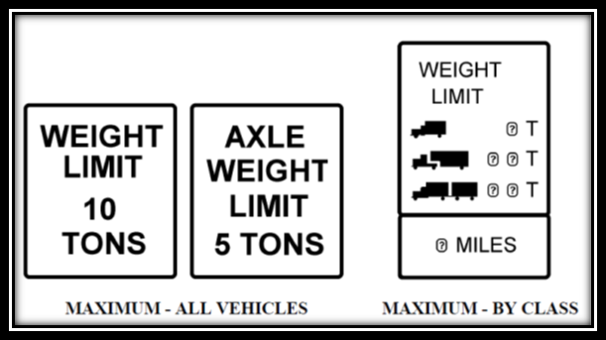
5) Speed Limits. The speed limit of a roadway tends to reflect the character of the roadway. Roads with higher speed limits are, generally, free flowing and have fewer access points. Roadways with lower speed limits are less free flowing, and have a greater number of access points. Those roadways with greater speed limits indicate that a roadway fits the desired characteristics of a truck route while the roadways with lower speed limits dictate further analysis.
Section 804.1504 - Designated Truck Routes and Maps.
All regulated trucks within the City shall be operated only over and along the designated truck routes established in this section as listed in Table 1. Unless otherwise prohibited, all streets under the jurisdiction of the state department of transportation (state roads) are designated truck routes;
Table 1. Designated Truck Routes
Street | From | To
44th Street | Wigmore Street | Norwood Avenue
Airport Center Drive W | Max Leggett Parkway | Main Street
Alta Drive | Rushing Branch | Faye Road
Alta Drive | Faye Road | SR 9A
Alta Drive | SR 9A | New Berlin Road South
Bay Street | AP Randolph Blvd. | Liberty Street
Bay Street | Park Street | Myrtle Avenue
Bowden Road | Philips Highway | Pepsi Way
Bowdendale Avenue | Philips Highway | I-95
Buffalo Avenue | 44th Street | Lawton Avenue
Bulls Bay Highway | Pritchard Road | Commonwealth Avenue
Bulls Bay Highway | Commonwealth Avenue | Beaver Street
Busch Drive | Heckscher Drive | Main Street
Chaffee Road N | Old Plank Road | Beaver Street
Chaffee Road S | Beaver Street | I-10
Commonwealth Avenue | Edgewood Avenue | Lane Avenue
Commonwealth Avenue | Ellis Road | I-295
Commonwealth Avenue | I-295 | Imeson Road
Commonwealth Avenue | Imeson Road | Jones Road
Devoe Street | Beaver Street | I-10 Ramps/Hammond Rd
Eastport Road | Main Street | Faye Road
Eastport Road | Faye Road | Heckscher Drive
Ellis Road | Normandy Blvd. | Beaver Street
Ellis Road | Beaver Street | 12th Street
Faye Road | Eastport Road | SR 9A
Faye Road | Alta Drive | New Berlin Road
Forest Street | I-95 | Park Street
Gator Bowl Blvd. | AP Randolph Blvd. | Arlington Expressway
Imeson Park Blvd. | Main Street | Busch Drive
Imeson Road | Commonwealth Avenue | Pritchard Road
Imeson Road | Pritchard Road | Garden Street
Mc Duff Avenue | I-10 | Commonwealth Avenue
New Berlin Road | Cedar Point Road | New Berlin Road East
New Berlin Road | New Berlin Road E | Alta Drive
New Berlin Road East | New Berlin Road | Heckscher Drive
New Berlin Road | Alta Drive | Heckscher Drive
Old Kings Road | Seaboard Coast Line Rd. | Edgewood Avenue
Old St. Augustine Rd. | I-95 | Philips Highway
Park Street | Forest Street | Bay Street
Pecan Park Road | I-95 | Int'l Airport Blvd.
Picketville Road | I-295 | Commonwealth Avenue
Picketville Road | Commonwealth Avenue | Beaver Street
Port Jacksonville Parkway | New Berlin Road | Alta Drive
Pritchard Road | Jones Road | Imeson Road
Pritchard Road | Imeson Road | Sportsman Club Road
Pritchard Road | Jones Road | Commonwealth Avenue
Pritchard Road | Commonwealth Avenue | Old Plank Road
Soutel Drive | Old Kings Road | New Kings Road
Talleyrand Avenue | Adams Street | 8th Street
Talleyrand Avenue | 8th Street | 11th Street
Western Way | Baymeadows Road | Southside Blvd
Wigmore Street | Talleyrand Avenue | 44th Street
Alternate Truck Routes
Street | From | To
Kernan Blvd. | Mc Cormick Road | Matthew Unger Drive
Kernan Blvd. | Atlantic Blvd. | Beach Blvd.
Kernan Blvd. | Beach Blvd. | Glen Kernan Blvd.
Kernan Blvd. | Glen Kernan Blvd. | J Turner Butler Blvd.
Kernan Blvd. | Matthew Unger Drive | Abess Blvd.
Kernan Blvd. | Abess Blvd. | Atlantic Blvd.
Mill Creek Road | Arlington Expressway | Atlantic Blvd.
Powers Avenue | Old Kings Road | University Blvd.
Richard Street | Bowdendale Avenue | University Blvd.
Shad Road | Hood Road | Philips Highway
Designated routes are illustrated on Maps T1, T1A, T1B, T1C, and T1D. They are attached and incorporated as a part of this ordinance as the description of the City of Jacksonville designated Truck Routes.
Operation on non-designated truck route. The driver of a regulated truck may travel over and along a street not designated as a truck route only as necessary to perform its business its destination lies on or within in a manner that minimizes the distance traveled over and along the non-truck route street. The driver of the truck must return to the designated truck route network by the shortest possible distance after completion of its business within a non-truck route street.
Section 804.1505 – Signage
The City Traffic Engineer is authorized to install adequate signage placed along designated truck routes at intersections of two (2) designated routes, and at reasonable intervals along designated truck routes.
Section 804.1506 – Evidence required for deviation; enforcement; penalties.
(a) Any person driving or in charge or control of any regulated truck deviating from the designated truck route system shall be prepared to present for the inspection of Jacksonville Sheriff’s Office (“JSO”) police officers the truck's log book, weight slips, delivery slips, or other written evidence of the regulated truck's origin and destination to justify the deviation from the designated truck route system.
(b) A violation of this Section shall constitute an irreversible and irreparable violation and will result in the immediate issuance of a civil citation by a JSO police officer pursuant to Section 804.301, Ordinance Code and Section 636.204, Ordinance Code. An irreversible and irreparable violation means a violation that is incapable of correction, repair or return to an original condition.
(c) A violation of this section shall constitute a class C offense, and shall result in a penalty of $100.00.
Section 2. Designating the Planning and Development Department to provide an education component.
The Planning and Development Department shall coordinate with the Jacksonville Sheriff’s Office to develop a program to educate the public about the location of truck routes and street functional classification.
Section 3. Effective Date. This ordinance shall become effective upon signature by the Mayor or upon becoming effective without the Mayor’s signature.
Form Approved:

_/s/Cherry Shaw Pollock______________________________________
Office of General Counsel
Legislation prepared by: Cherry Shaw Pollock
GC-#1170615-v1-Draft_Ordinance_Creating_Truck_Routes_112117

